NYSSLS Daily Lesson Plan
Instructional Unit:  Weather and Climate  Air masses, Fronts and Weather  LESSON: AIR MASSES |  |  |  |  |  | Period(s) of Unit:  6 periods |  | Date:
Materials/Resources/Links:  Weather Lab | Smithsonian Science Education Center (si.edu)  Make a Thunderstorm | Center for Science Education (ucar.edu) |  |  |  |  |  |  |  | Course:  Earth and Space Science
Special Notes for Lesson:

ANCHORING PHENOMINON: Students will be asked to remember the children’s story of the country mouse and the city mouse. The reason being the personalities of the mice were determined by the environment in which they lived.

Standards:
Science and Engineering Practices  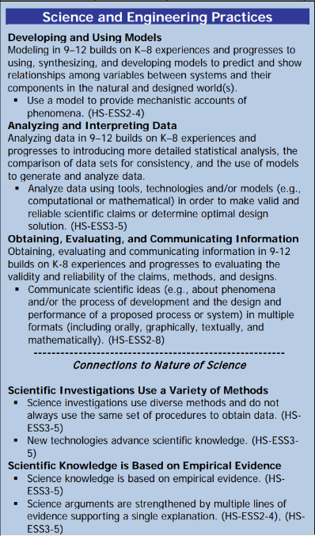 |  |  | Disciplinary Core Idea(s)  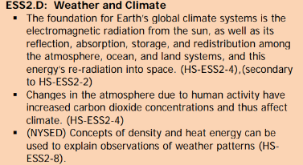 |  |  |  | Cross Cutting Concepts  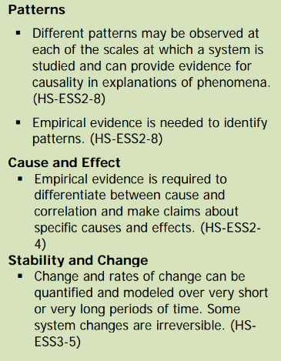
Performance Level
NYS Level 5 | NYS Level 4 |  |  | NYS Level 3 | NYS Level 2 |  |  | NYS Level 1
Collect and analyze global and regional weather data using tools, technologies, and /or models to communicate in multiple formats how the movement and interactions of airmasses result in changes in weather conditions. | Evaluate data and communicate information to explain hoe the movement and interactions of air masses result in changes in weather conditions |  |  | Evaluate data and communicate information to identify patterns of movement and/or the resulting changes in weather conditions. | Use data to identify the patterns of movement or the interactions of air masses and the resulting change in weather conditions  or to identify factors that drive the movement of air masses or from given weather conditions, identify evidence from maps that support these conditions. |  |  | Use data and/or patterns of movement and interactions of air masses to identify the resulting changes in weather conditions or identify one factor that drives the movement of air masses or from those provided, use evidence from maps to account for weather conditions or given weather conditions, identify evidence found on maps that account for one of these conditions.
Clarification Statement  Examples of evidence sources could include station models, surface weather maps, satellite images, radar and accepted forecast models. Emphasis should focus on communicating how the uneven heating of the Earth’s surface at frontal boundaries and resulting weather phenomena. |  |  |  |  | Assessment Boundary  Analysis is limited to surface weather maps and general weather patterns associated with High and Low pressure systems
Connection to Anchoring Phenomenon:

Air masses take on the properties of the source region they formed over, very similar to the country mouse and the city mouse.

Essential Question(s):

What personality traits would you expect from the country mouse and the city mouse.? Why?

What names would you give to the air masses to describe its characteristics?

How did the air masses get their properties?

What happens when 2 different air masses interact?

Instructional Strategies & Learning Tasks: Engage, Explore, Explain, Elaborate, Evaluate
Engage: images, video clip or data… |  | Students will be asked if they remember the story of the country mouse and the city mouse. They will be asked to describe what they would expect the personality traits of the two mice to be, to make the connection that location can determine personality traits.
Explore: Students investigate, experiment, hands-on activity…. |  | Students will be given temperature and humidity data for different locations. Students will analyze the data and devise their own name for the different air masses.
Explain: Students share their observations and evidence to explain their understanding…possible whole group/class discussion… |  | Students will share their air mass names with the class and discuss why they chose the name they did. The teacher will then discuss the real names of these air masses and locations in which they might form.
Elaborate: Students apply the science concepts they’ve just learned… |  | Students will engage in an online lab and determine other locations of these air masses and more in depth characteristics.  Afterwards, they will then be given temperature and humidity data for an unknown location and determine where that location is on a map using it’s air mass characteristics.  Students will also observe what happens when different air masses interact. They will also investigate the conditions of an air mass that produce “Air Mass” Thunderstorms.
Evaluate (Formative Assessment): Student learning is evaluated. |  | Students will be evaluated bases on teacher questions, quizzes and tests.

Copy and paste student worksheets below:
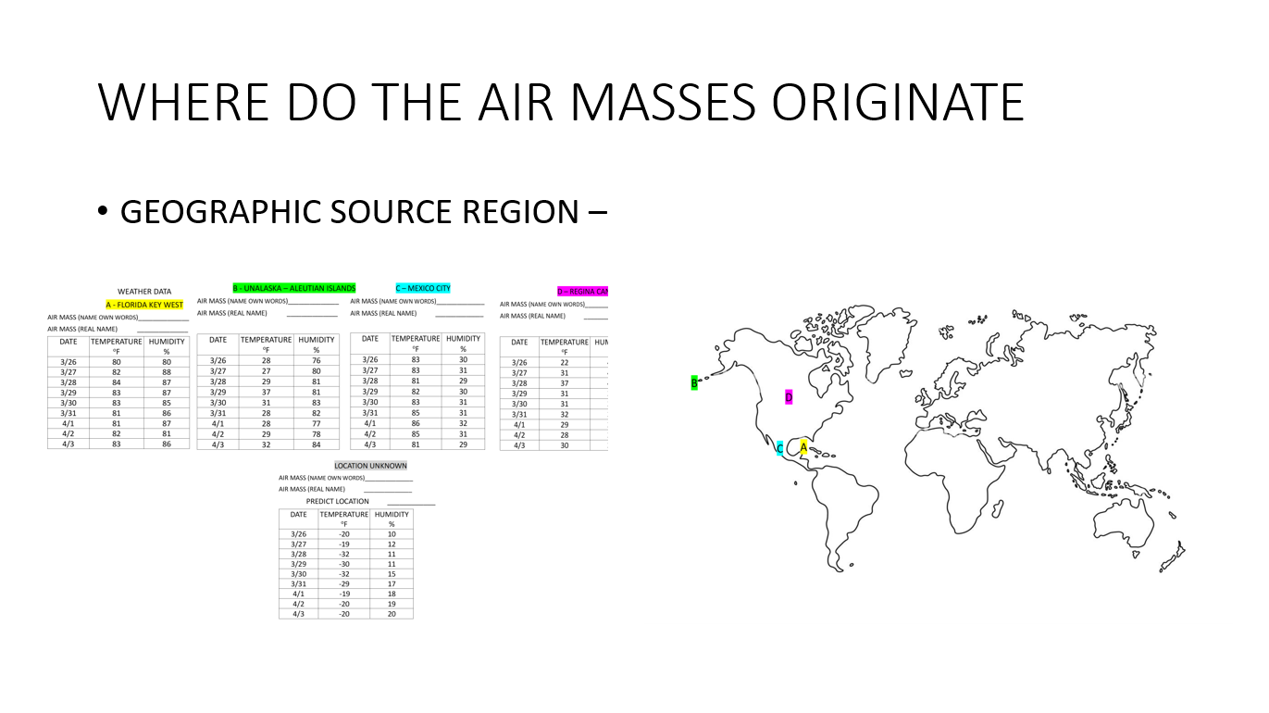

ENLARGED VIEW OF THIS INFORMATION BELOW
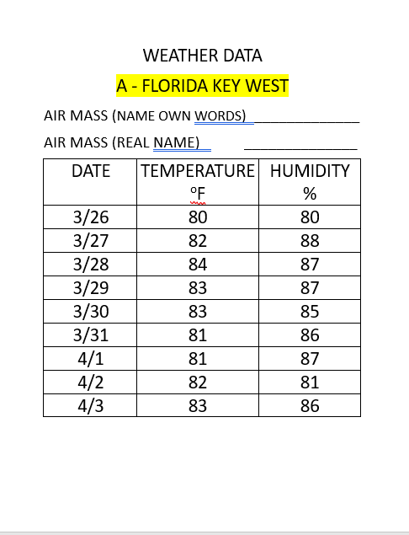
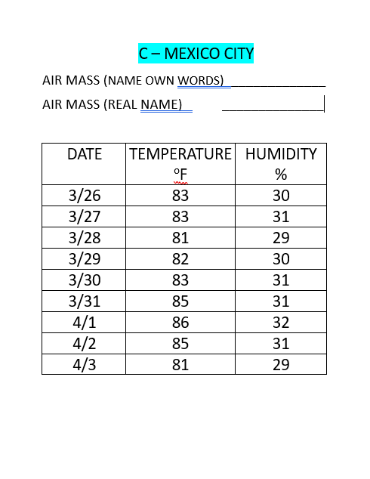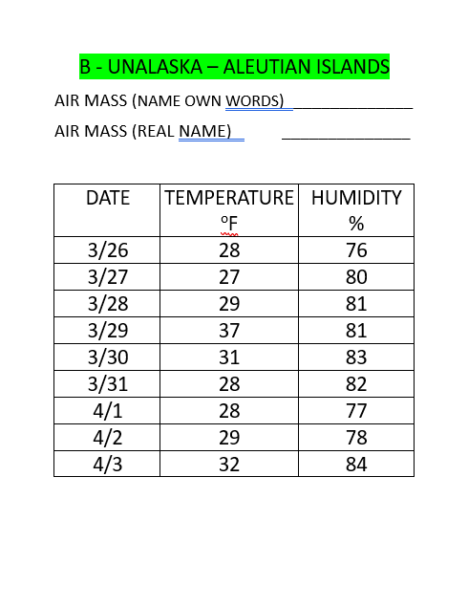

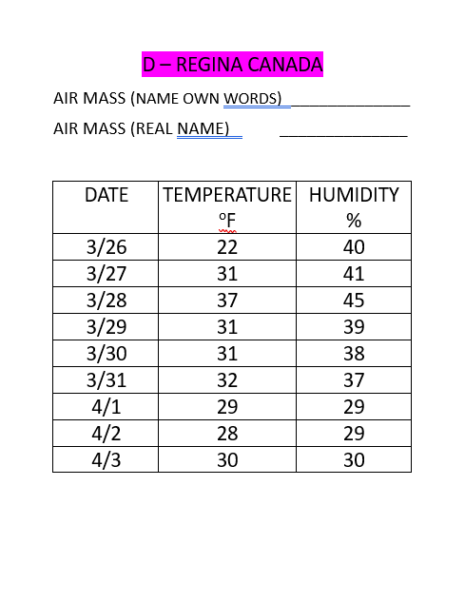

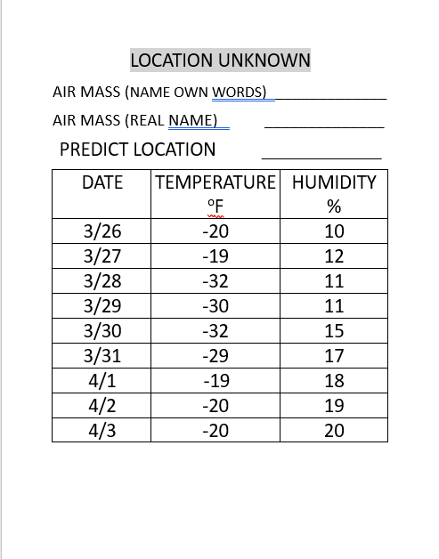

AIR MASS DATA LOCATIONS ON MAP
